**Steps to pass table in FM**

1. Go to tcode se37 and create a FM starting with Z/Y

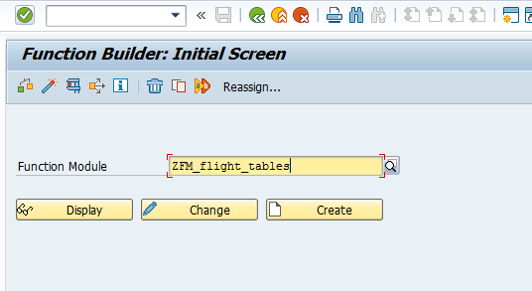

1. In the import tab, add two parameters ( from table SFLIGHT)

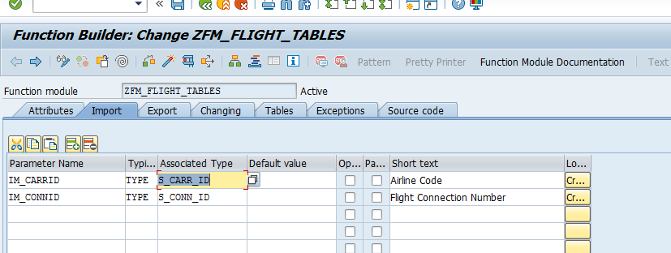

3. In the changing tab, declare an internal table it_sflight of **table type** ZTT_SFLIGHT (created through se11)

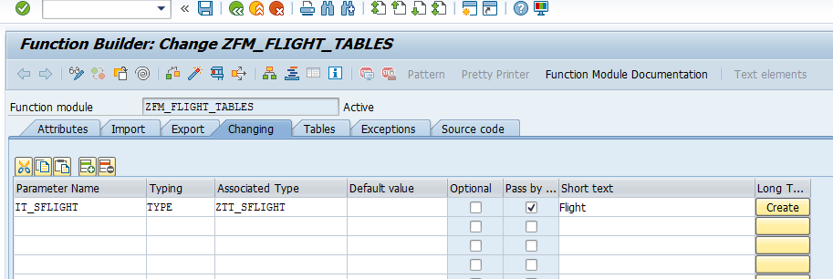

4. In the tab source code, add the below logic

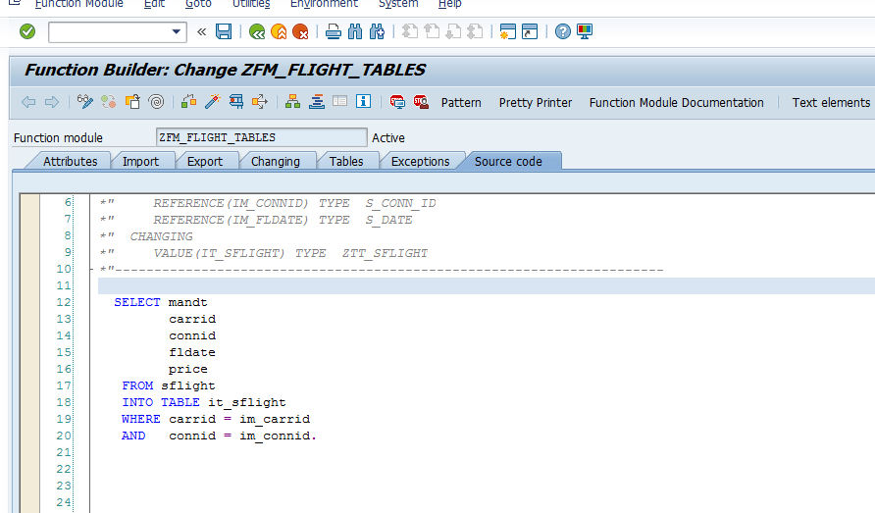

5. Save and activate the FM.

6.Create a report , declare two parameters as shown below. Then call FM ZFM_FLIGHT_TABLES.

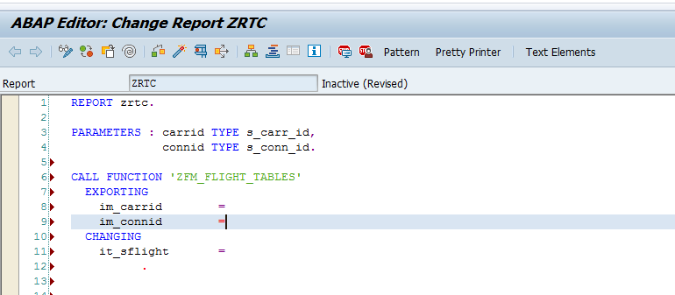

6. Modify the logic as below.

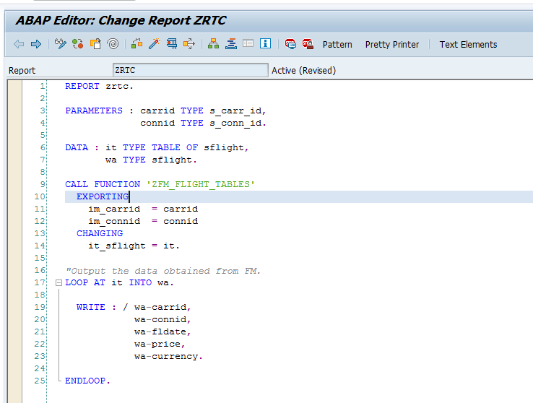

7. The expected output is as below

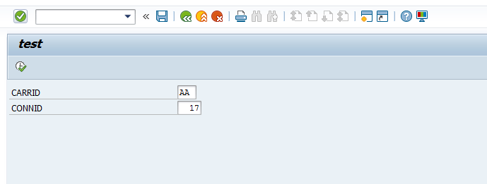

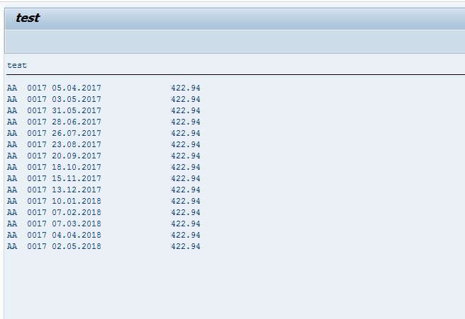

**Code for reference:**

REPORT zrtc.  
  
PARAMETERS : carrid TYPE s_carr_id,  
             connid TYPE s_conn_id.  
  
DATA : it TYPE TABLE OF sflight,  
       wa TYPE sflight.  
  
CALL FUNCTION 'ZFM_FLIGHT_TABLES'  
  EXPORTING  
    im_carrid  = carrid  
    im_connid  = connid  
  CHANGING  
    it_sflight = it.  
  
*"Output the data obtained from FM.*  
LOOP AT it INTO wa.  
  
  WRITE : / wa-carrid,  
            wa-connid,  
            wa-fldate,  
            wa-price,  
            wa-currency.  
  
ENDLOOP.